- Come up with the routing tables for all the routers: A, B, C, D, E, F, and G. Host 70.0.0.9 must receive his packets only from router E. All other traffic to network 70.0.0.0 may arrive from other routers. Router H is the router used to access the Internet. Your routing tables must use the shortest possible route.

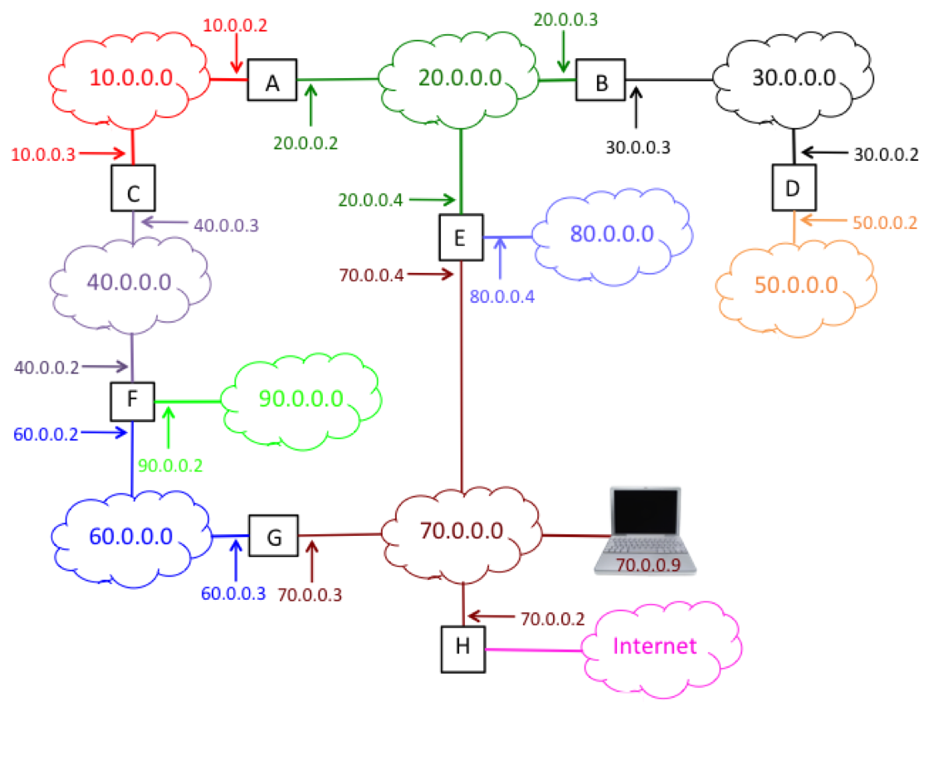

2. Explain fragmentation as it relates to datagrams. Why is it necessary? Where does it occur? When and where are the fragments reassembled? Give examples and be as specific as possible.
3. What is the function of the Time To Live (TTL) field in a datagram header?
• 4.Should a router give ICMP messages priority over normal traffic? Why or why not?

